TOWN OF SOUTHBURY
OFFICE OF THE FIRST SELECTMAN
501 Main Street South
Southbury, Connecticut 06488
(203) 262-0647
Fax: (203) 264-9762

Submitted electronically

January 17, 2013

Mr. Dan Esty
Commissioner of Connecticut Department of Energy and Environmental Protection
79 Elm Street
Hartford, CT 06106-5127

Dear Dan,

I am pleased to support the Town of Southbury’s revised application for a MicroGrid to support two of the municipality’s critical facilities. I believe that Southbury offers an ideal campus for a “proof of concept” project and is the logical next step in our efforts to make Southbury more resilient. Our approach is a cautious, phased approach:

- In Phase 1, the proposed project connects two contiguously located municipal owned buildings, Town Hall and the Senior Center in a Microgrid. In the event of a power outage, the existing generator at the Senior Center will provide energy to both buildings, enabling the continued operation of town administrative functions, phone system, internet access and the operation of an emergency shelter. By linking them together via the MicroGrid, we will also be able to manage load optimally and improve reliability.
- In Phase 2, the MicroGrid would be extended to include two of our Region 15 Schools, the Main Firehouse and the Police Building which houses our Emergency Operations Center. Including the two schools and the Firehouse would greatly enhance the sheltering capacity of the Town. Given our position adjacent to Interstate-84, the additional sheltering could also prove very beneficial to the State.
Our proposal was put together by volunteers from our newly constituted Energy Task Force with the assistance of Honeywell and the Connecticut Center for Advanced Technology. If our application is accepted, we would engage a professional to manage the project from that point forward.

I hope you will consider our application for the next phase. Should you have any questions, please do not hesitate to contact my office.

Very truly yours,

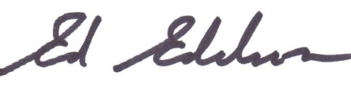

Ed Edelson, First Selectman

