July 7, 2014

RFI #14DOT7002

State of Connecticut
Department of Transportation

Request For Information (RFI)

Electric Vehicle (EV) Fast Charger -
Statewide Deployment & Operation

For the State of Connecticut
Department of Transportation

Issue Date:
July 7, 2014

Question Cutoff Date:
July 21, 2014 @ 2:00 pm EDT

Response Deadline:
August 4, 2014 @ 2:00 pm EDT

Issued by:
Connecticut Department of Transportation
2800 Berlin Turnpike, P.O. Box 317546
Newington, CT 06131-7546
Requirements and Deadlines for Questions and Responses
This Request for Information (RFI) outlines the type of information being solicited from vendors. Vendor(s) choosing to respond to this RFI shall have four (4) weeks from the date of issuance (July 7, 2014) to respond.

All questions must be submitted in an electronic mail format and be addressed to Richard.Hanley@ct.gov by no later than 2:00 p.m. Eastern Daylight Time on July 21, 2014.

Parties desiring to respond to this RFI must do so in writing, providing one original and five (5) complete copies of the submitted response. Complete responses are due no later than 2:00 p.m. Eastern Daylight Time on August 4, 2014. Late responses may or may not be considered, depending upon the needs of the Department of Transportation. The postal address for RFI #14DOT7002 is:
Mr. Richard C. Hanley, P.E.
Connecticut Department of Transportation
2800 Berlin Turnpike, P.O. Box 317546
Newington, CT 06131-7546
Attn: RFI #14DOT7002

All questions and answers will be posted as an addendum to this RFI on the State of Connecticut “State Contracting Portal” at http://www.biznet.ct.gov/SCP_Search/Default.aspx?AccLast=2 . DO NOT INCLUDE references to your company name; proprietary, confidential or other sensitive information when submitting questions for the RFI if you do not want it to be disclosed.

Request for Information Specifications

- Subject and Purpose
This Request for Information (RFI) seeks information for Electric Vehicle (EV) Fast Charger Statewide Deployment and Operations. Its purpose is to provide the State of Connecticut (the “State”) Department of Transportation (CT DOT) and Department of Energy and Environmental Protection (CT DEEP) with sufficient information and knowledge to proceed with a formal Request For Proposals (RFP) that would address either the whole or essential portions of a solution.
- Description
The State intends to continue the expansion of EV charging using Direct Current (DC) Fast Charger stations located along major highway corridors throughout the State. This will enable EV operators to drive with confidence by always being within reasonable range of a DC Fast Charger supply network. These chargers, capable of charging a minimum of fifty (50) miles of range in thirty (30) minutes or less, will be located in a variety of public locations, including but not limited to restaurants, convenience stores, gas stations, retail establishments, or other appropriate locations that meet the conditions described herein.
Initial plans specify up to ten (10) additional DC Fast Charger stations. Each station will support the general public’s use of Battery Electric Vehicles (BEV) and Plug-in Electric Vehicles (PEV) by providing additional charging capacity at geographically diverse sites. This network of DC Fast Chargers will instill “range-confidence” to BEV and PEV drivers, knowing this charging network can extend vehicle range when needed. This network also addresses CT DOT concerns both to maintain EV motorist safety and to maintain uninterrupted traffic operations by minimizing the possibility for “out-of-fuel” EV’s becoming stranded on the State’s highway network.
- Requirements
Location
- Approved sites (“stations”) shall be within one (1) mile of state preferred site locations (see Attachment 1 for preferred station locations)
- Shall be available to the public twenty-four (24) hours per day, seven (7) days a week
- Shall provide access to a public restroom including sink, running water and flush toilet
- Shall be in a well-lit and secure area
- Shall have an ADA-compliant site plan
- Should offer ancillary motorist services including, but not limited to, food, water and air for tires
- Should have visible station location and signage from the highway(s) being served
Electrical Supply
- Shall be verified by the electric utility serving the site that three (3) phase power is available
- Shall have a separately-metered electrical service dedicated solely for EV charging
Equipment
- Shall use a four-hundred eighty (480) volt, three (3) phase power input
- Shall have forty (40) kW minimum rated power charging capacity
- Shall be equipped at initial installation with both CHAdeMO and SAE Combo charge capability
- Shall have two (2) separate DC Fast Charger units installed at each station
- A minimum of one (1) DC Fast Charger at each station shall service one (1) stall dedicated to EV charging only
- Both DC Fast Chargers at a station shall be capable of being operated simultaneously
- Shall have a charger cord length of either twenty (20) feet or the minimum required to charge any EV when located in an adjacent charging stall
- Shall not require vehicles to make illegal traffic movements to enter or exit charging stall
- Shall have the ability to communicate with vehicle charging management systems
- Shall have a built-in electronic diagnostic signal capability
- Shall be rated for outdoor operation by a nationally recognized testing laboratory
- Shall include all fabrication and installation of EV-charger related signage (including parking, EV charging, sponsorship, & trailblazing signage) as prescribed by the State (See Attachment B)
- Shall include installation of single-color pavement markings as prescribed by the State
- Shall include a custom weatherproof charger “wrap” or “skin” as prescribed by the State
Payments and Transaction Processing
- Payment technology systems shall be compliant with the Open Charge Point Protocol (OCPP).
- Proposed payment system shall be “open access,” accepting all major credit and debit cards, with no additional required contact.
- Shall accept State of Connecticut MasterCard Purchasing “P-Cards “ (see http://das.ct.gov/cr1.aspx?page=36 for P-Card explanation)
- Transaction processing communications equipment shall be real-time
- Transaction processing communications equipment should be cellular-based
- Should have no cost to user for the first six (6) months of operation (at the discretion of the State)
- Shall NOT accept cash or coins
- Should have a single charge duration limited to 45 minutes to preserve throughput capacity
- Shall have the cost of charging identified and posted on the charger.
- Charging costs shall be capable of being assessed using a variety/combination of methods acceptable to the State (i.e. – time connected to charger, kilowatt-hours dispensed, etc.)
- Payment to use charger shall not be limited to pre-paid or subscription services
- User payment hardware and software required shall be upgradeable for evolving technology needs
- Shall use industry-standard security protocols for electronic transaction processing
- State personnel shall have access to station operation, data collection and usage data for a minimum of three (3) years after chargers become operational.
- Jointly-developed usage data and reports shall be submitted quarterly. Said report should contain, but not be limited to, cumulative number of vehicles charged; number of different vehicles versus visits by the same vehicle; charging and usage times; maintenance issues; and, lessons learned from charger operations. All data will become public and is subject to State of Connecticut Freedom of Information (FOI) laws.
Business Plan / Partnerships / Sponsorships / Advertising / Ownership
- Shall include proposed business model(s) for the first three (3) years of operation
- Partnerships, sponsorships, advertising or other revenue-generation and/or cost-mitigation proposals are encouraged.
- Full ownership, lease, lease-purchase, land-lease, rental and other arrangements for ownership, landlord / tenant rental, concessionaire and/or stewardship model proposals are encouraged.
- Charger availability and ownership arrangements shall remain in place for three (3) years from date of first operation. At no time shall EV Chargers become unavailable due to ownership issues.
- The State and/or its designee shall have right of first refusal for lease and/or purchase of the equipment at the end of the agreement.
Permits and Construction
- Shall have demonstrated site control before construction begins, including documents displaying (1) ownership of, a leasehold interest in, or a right to develop a site for the purpose of constructing the EV Charging Station; (2) an option to purchase or acquire a leasehold site for such purpose; or (3) an exclusivity or other business relationship granting the right to sell, lease or grant possession or occupation of the site for such purpose.
- Shall be ready for construction no more than three (3) months after contract execution
- Shall be permitted, installed, tested and operating properly within six (6) months from the date of contract execution
Operations and Maintenance
- For three (3) years after installation, the following services shall be provided at no additional cost to the State:
  - Management of all associated maintenance and operation as well as warranty services
  - All minor operational maintenance, including charger cord replacement, shall occur within forty-eight (48) hours of initial reporting
  - All software and hardware updates as prescribed by DC Fast Charger manufacturer.
  - Dedicated phone number and email for complaints, both to be posted on charger.
- Sample Response Outline
The following is a suggested outline and page counts for a response to this RFI. This outline is intended to minimize the effort of the respondent and structure the response for ease of analysis. However, respondents are free to develop their responses as they see fit.
Section 1 – Proposed Solution
Briefly describe the proposed solution architecture, including charger locations; equipment types/models; estimated total cost and other pertinent data. (4-6 pages, with one (1) network location map, one (1) charger specification, and one (1) typical EV Charger Location site plan.)
Section 2 – Conceptual Alternative(s)
Briefly describe conceptual alternative(s) if any other than the proposed solution, including proposed charger locations, equipment type, estimated total cost and other pertinent data. (2-3 pages, with one (1) network location map).
Section 3 – Feasibility Assessment
Briefly describe the feasibility of the proposed solution and all conceptual alternatives (if any). (one (1) page per solution / alternative)
Section 4 – Cost and Schedule Estimates
Provide initial “ballpark” cost for proposed solution and conceptual alternatives (if any). Also discuss any non-recurring or annually recurring costs. Discuss any cost tradeoffs or cost-sharing opportunities. Finally, describe any schedule considerations. (five (5) pages per solution / alternative, to include one (1) cost page and one (1) project scheduling page)
Section 5 – Business Case
Provide an overview business case for the proposed solution and all conceptual alternatives (if any), out to year 3, with additional ownership options to year 5. (4 pages per solution/alternative)
Section 6 – Corporate Expertise
Briefly describe your company, your products and services, history, ownership, financial information, access to financing and any other relevant information. (No suggested page count)
Section 7 – Similar Projects
Describe any projects that you have been involved in that are similar to this RFI, including management approach, security concerns, quality control, outcomes to date and relevant lessons learned. Include a reference name with contact information for any similar system to the one specified by this RFI (2-3 pages per project).
Section 8 – Additional Material
Include any other materials, suggestions and discussion you deem appropriate. Also include any comments on the structure of the requirements for a formal Request for Proposal (RFP) response. (No suggested page count.)
- Information Exchange
The State may consider requesting further contact with one or more proposers if necessary. The State reserves the right to contact proposers at no obligation to the State.
- Disclaimer
This RFI is issued solely for information and planning purposes and does not constitute a solicitation. All information in response to this RFI that is marked Proprietary will be handled accordingly. Responses to the RFI will not be returned. Responses to this notice are not an offer and cannot be accepted to form a binding contract. This solicitation of information should not be considered an opportunity to market to the Department of Transportation, nor to any entity for the State of Connecticut. Respondents are solely responsible for all expenses associate with responding to this RFI.
- Contact Information
The following is the Point of Contact for the RFI:
Mr. Richard C. Hanley, P.E.
Connecticut Department of Transportation
2800 Berlin Turnpike, P.O. Box 317546
Newington, CT 06131-7546
Email: Richard.Hanley@CT.gov
Attn: RFI #14DOT7002

Attachment 1: DC Fast Charger Preferred Locations
Listed below are preferred site locations (descending priority order) for the DC Fast Charger network:
- Between Groton and Stonington, within 1 mile of an I-95 exit
- In Fairfield, within 1 mile of an I-95 exit or at the service plaza area on I-95 Northbound
- In Cromwell, within 1 mile of an I-91 or CT-9 exit
- In Enfield, within 1 mile of an I-91 exit
- Between Union and Willington, within 1 mile of an I-84 exit
- In Danbury, Bethel or Brookfield, within 1 mile of an I-84 or US-7 exit
- In Waterbury, within 1 mile of an I-84 or CT-8 exit
- In Killingly, within 1 mile of an I-395 exit or within 1 mile of US-6
- In North Canaan, within 1 mile of US-44 and US-7
- In Norwich, within 1 mile of an I-395 or CT-2 exit

In lieu of these preferred locations, the state would consider evaluating proposer’s alternate EV Fast Charger locations provided the following guidelines are met:
  - All sites shall be located on land NOT owned by the State of Connecticut
  - All sites shall be located in the State of Connecticut
  - All EV chargers shall be within one (1) mile of the highway exit for limited access highways
  - No more than ten (10) sites may be considered; and
  - Less than ten (10) new sites would be considered ONLY if they satisfy all criteria.
  - EV’s operating on the following highway corridors should never be more than 30 miles driving distance from a DC Fast Charger (as defined by this RFI):
    - Interstate: 84, 91, 95, 291, 384, 395, 691
    - U.S.: 1, 5, 6, 7, 44
    - State: 2, 8, 9, 11, 15, 72, 85
(DC Fast Chargers @ I-95 Southbound Darien service plaza, I-95 Northbound Madison service plaza, and CT-15 Northbound Greenwich service plaza may be considered for this analysis)

Attachment 2: State of Connecticut – EV Charger-related Signage
Dedicated Stall for EV Charging
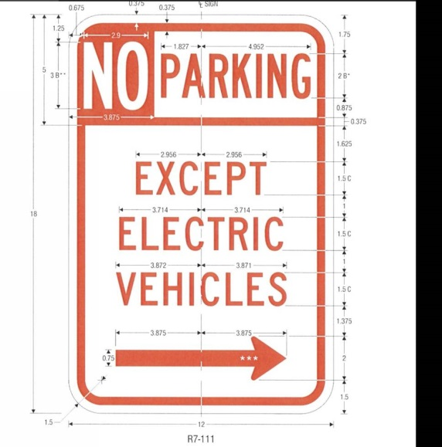(Change Arrow as Applicable)
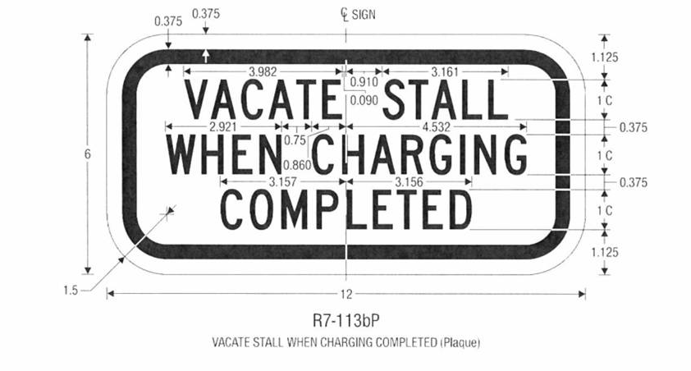
Sponsorship
Mainline Trailblazing (if sign warrants met), Trailblazing (use applicable direction arrow underneath)
