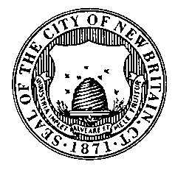
CITY OF NEW BRITAIN
Finance department
www.newbritainct.gov
EST. 1871

CITY OF NEW BRITAIN

NOTICE INVITING BIDS

Date: April 15, 2019

Bid No.: 3959

Bid Name: 87 Octane Unleaded Gasoline.

Summary: Furnish and Deliver Unleaded Gasoline to various City Locations for a one (1) year period, on or about May 17, 2019 to May 15, 2020.

Pre-Bid: None

Bonding: None

Date and Time of Bid Opening: May 06, 2019 at 11:00 AM

Specifications are Available On-Line: http://bids.newbritainct.gov

Please note that it is the vendors’ responsibility to check on-line prior to bid opening to determine if addenda have been issued.

Jack Pieper
Purchasing Agent

