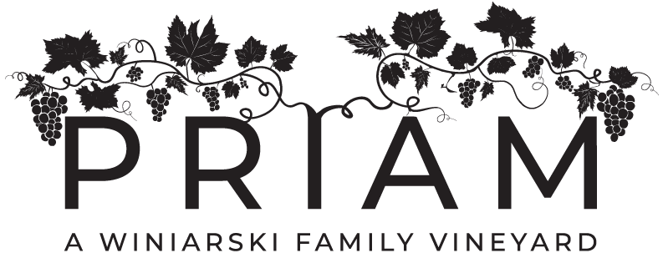
RETAIL/WHOLESALE PRICING

(1010) Jeremy River White ........................................Retail- $25.00 bottle - $14. glass
Wholesale- $17.50 -- $210.00 per case, 42 PTS
(1000) Salmon River White.........................................Retail- $25.00 bottle - $14. glass
Wholesale- $17.50 -- $210.00 per case, 42 PTS
(1015) Riesling.............................................................Retail- $27.00 bottle - $14. glass
Wholesale- $18.90 -- $226.80 per case, 43 PTS
(1014) Gewurztraminer...............................................Retail- $27.00 bottle - $14. glass
Wholesale- $18.90 -- $226.80 per case, 43 PTS
(1005) Barrel Select Chardonnay - (Aged 24 Mo.)....Retail- $27.00 bottle - $15. glass
Wholesale- $18.25 -- $219.00 per case, 48 PTS
(1007) Blackledge Rose'(Sweet)..................................Retail- $25.00 bottle - $13. glass
Wholesale- $17.50 -- $210.00 per case, 42 PTS
(1065) Salmon River Rose’(Dry)................................Retail- $25.00 bottle - $14. glass
Wholesale- $17.50 -- $210.00 per case, 43 PTS
(1012) Westchester Red ​­- 14 months barrel-aged.......Retail- $25.00 bottle - $14. glass
Wholesale- $17.50 -- $210.00 per case, 43 PTS
(1066) Blackledge Red- 14 months barrel-aged,.........Retail- $30.00 bottle - $16. glass
Wholesale- $21.00 -- $252.00 per case, 43 PTS
(1002) Salmon River Red - 14 months barrel-aged ....Retail- $30.00 bottle - $16. glass
Wholesale- $21.00 -- $252.00 per case, 43 PTS
(1068) St. Croix -Bourbon Barrel Aged .......................Retail- $45.00 bottle
Wholesale- $31.50 -- $378.00 per case, 45 PTS
(1118) Le Petit Rose’ Sparkling Wine .….…………Retail- $28.00 bottle - $14. glass
Wholesale- $19.50 -- $234.00 per case, 44 PTS

